RESUME

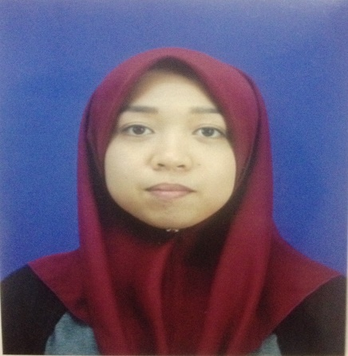

|  |
| --- |
| **CONTACT INFO** |

NAME : NOR SYUHADA BINTI ROSLAN

CURRENT ADDRESS : BLOK 22-G-03 APRT RISTA VILLA, TAMAN PUTRA

PERDANA, 47130 PUCHONG SELANGOR

MOBILE : 011-23082989

EMAIL : chuada69@gmail.com

PERMANENT ADDRESS : BLOK 22-G-03 APRT RISTA VILLA, TAMAN PUTRA

PERDANA, 47130 PUCHONG SELANGOR

|  |
| --- |
| **PERSONAL PARTICULAR** |

AGE : 20 YEARS DATE OF BIRTH : 9 AGUST 1995

NATIONALLY : MALAYSIA GENDER : FEMALE

MARTIAL : SINGLE I/C : 950809-14-5044

|  |
| --- |
| **EDUCATION** |

HIGHEST EDUCATION LEVEL : DIPLOMA IN BUSINESS MANAGMENT

FIELD OF STUDY : BUSINESS MANAGMENT

MAJOR : BUSINESS

COLLEGE : KOLEJ POLY-TECH MARA,BANGI

**LANGUAGES PROFICIENCY**

|  |  |  |
| --- | --- | --- |
| LANGUAGE | SPOKEN | WRITTEN |
| MALAY | EXCELENT | EXCELENT |
| ENGLISH | GOOD | GOOD |

|  |
| --- |
| **SKILLS AND KNOWLEDGE** |

COMPUTER SKILL

*MICROSOFT OFFICE (EXCEL, WORD AND POWERPOINT)

*GOOD PUBLIC RELATION SKILLS

*GOOD IN PRESEMTER SKILLS

|  |
| --- |
| **PERSONAL DETAILS** |

1. WORKING AT 7-ELEVEN SDN BHD

AS A SALES ASSISTANT

14/11/2012 – 22/05/2013

1. CASHIER IN 7-ELEVEN

SINCE 2012-2013

1. WORKING AT TESCO

AS A PERSONAL SHOPPER

NOVEMBER – DECEMBER 2014

1. PUSAT TUISYEN

AS A ADMIN

|  |
| --- |
| **EXPECTED SALARY** |

EXPECTED SALARY RM 1500- RM 2000 PER MONTH

|  |
| --- |
| **REFERENCES** |

NAME : AINUN NADIRAH

POSITION : LECTURE

PHONE : 013-3729115